How to select a softball glove

O SELECT A SOFTBALL GLOVEW TO SELECT A SOFTBALL GLOVE
Handling the ball well requires a properly sized glove. Glove size is measured by the distance in inches from the top of the glove index finger, through the inside of the pocket, to the bottom of the glove. Gloves range in size from 9 inches for small, youth players, to 14 inches for larger, adult players. Factors to determine the best glove size include age, playing position and individual fit. New gloves should be broken in before use to make them more flexible and easier to use.

Step 1
Consider the player's age. Most gloves intended for younger players are designed for general use rather than being built for specific positions. This is because younger players are much more likely to play a wide range of positions instead of specializing in one area. Depending on the size of the player, particularly their hands, you may need a glove smaller or larger than the general age recommendations provided below.
Avoid buying a glove that is too large for a young player. While a larger glove may make it easier to catch balls, it prevents the player from developing proper fielding skills.
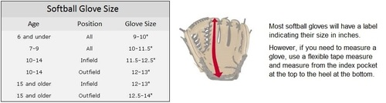
Step 2
When a player gets older, more specialized gloves are available to suit the needs of specific positions. The more ground a position player has to cover, the larger their glove's spread usually is. Outfielders typically use larger gloves with deep pockets to help catch fly balls. Infielders perform better with a slightly smaller glove that allows for quick transfer from the glove to the throwing hand.
- Second base players tend to wear the smallest gloves, typically 11.75 inches
- Middle infielders, including pitchers, tend wear gloves between 12 and 12.5 inches
- Players who change positions frequently and may also be placed in the outfield tend to wear utility gloves measuring 12.75 to 13.25 inches
- Outfielders tend to wear gloves measuring 13.5 to 14 inches
First base and catcher use different gloves than the rest of the field. First base requires a larger glove to improve a player's reach for the ball -- this makes it easier to stretch and catch the ball while keeping a foot on the bag. Catchers have to handle pitches delivered at high speeds. As a result, the gloves spread is very wide and also features extra padding to make the pitches less painful to handle.
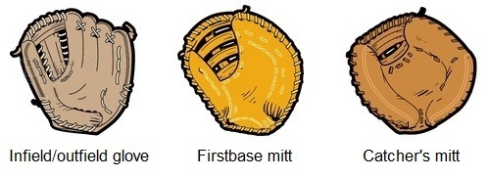

Step 3
Find a glove with the best fit. A glove that fits properly should allow for the full extension of the fingers, without running into obstruction from the padding. The glove should feel snug, but not tight over the palm area. Many times, the wrist strap needs to be adjusted so that it fits snugly on the hand and wrist. You should be able to move the glove without it slipping around on the hand, and the glove should be easy to open and close.

For more information, watch the following videos on YouTube:
- Tips on Proper Softball Glove Sizing
- How to Break in a Glove

